Josh (right) started at New Hope a year ago, and he continues to serve with dedication. He finds joy in giving back, knowing that even small tasks can make a meaningful difference.
After retiring, Jeff (left) felt called to serve with Josh in the warehouse. He has quickly become a reliable presence, helping behind the scenes and making a real difference with each task.
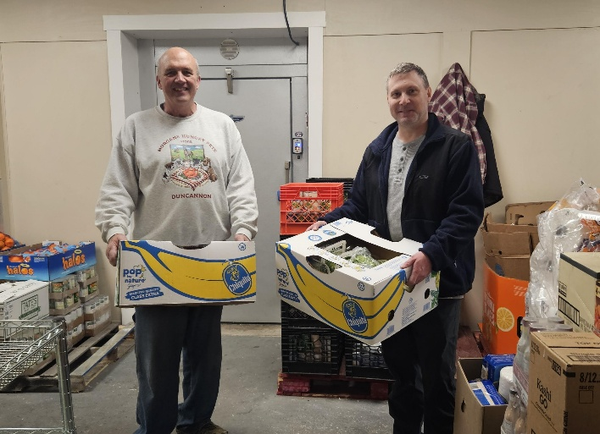
Together, Josh and Jeff reflect the heart of our volunteer community. Their service shows love behind the scenes, reminding us of the incredible work of our volunteers and all who give to New Hope.

And a harvest of righteousness is sown in peace by those who make peace. James 3:18

Need Help?
If you or someone you know needs help with food or dealing with a financial crisis, please contact us.
(717) 432-2087

Wish List:
• Canned meats and peanut butter
• Canned veggies/fruit
• Personal care items
• See website for specific needs by Center www.nhm-pa.org

Red Land Center Volunteer Recruiting Event
Friday, April 24, 2026
Please arrive at 12PM. Program starts at 12:15PM

